Table of Contents

1. Downloading and Installing Swiffy Extension: 2

2. Converting Animated flash files to generate Swiffy HTML output 2

a) Remove the reference to the "ui" script in the properties panel from the FLA source 2

b) Adding Script and Labels to the animated FLA 2

c) Converting Audio Files from WAV to MP3 4

d) Generating Swiffy HTML Output 4

e) Cleaning FLA files to generate clean Swiffy HTML output 5

f) Updating the XML and generating the HTML page 7

3. Integrating Swiffy with the HTML player 8

4. Running the HTML Player for checking Swiffy HTML and MCQ HTML output 8

5. Converting Quiz/MCQ flash files to generate HTML output 9

## Downloading and Installing Swiffy Extension:

**Step 1:** [Download Swiffy Extension](https://developers.google.com/swiffy/convert/flash-extension)

**Step 2:** Close Adobe Flash Application if open; and Install the downloaded extension using Adobe Extension Manager by following the steps listed below:

* Double click the downloaded Swiffy extension (swiffy.1.1.1.mxp)
* This will open **Adobe Extension Manager** Application; if installed.
* If Adobe Extension Manager is not installed you will need to install it before you can install the Swiffy extension. Download the relevant version from [this page](http://www.adobe.com/exchange/em_download/).

## Converting Animated flash files to generate Swiffy HTML output

### Remove the reference to the "ui" script in the properties panel from the FLA source

**Step 1:** Open the animation FLA source file and delete the reference to the "ui" script shown in the image below.

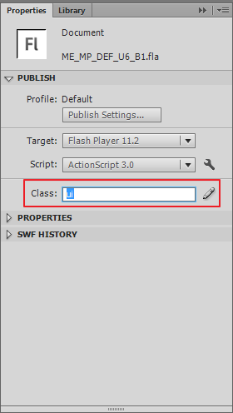

### Adding Script and Labels to the animated FLA

**Step 1:** Go to **Commands > Run Command**

**Note:** The layer containing vocal audio is required to have the name "**Audio**" and the layer containing sound effects is required to have the name "**scensound**"

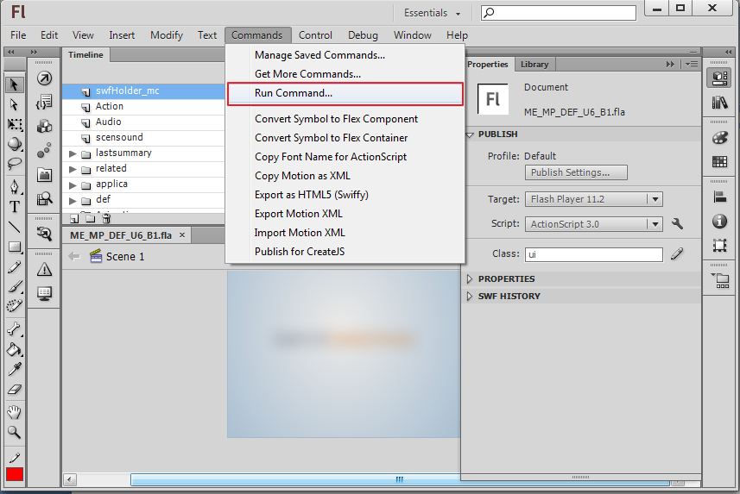

**Step 2:** Select the **01_AddScriptsAndLabels.jsfl** file supplied in the **JSFL_templates/Animations** folder and **click Open**.

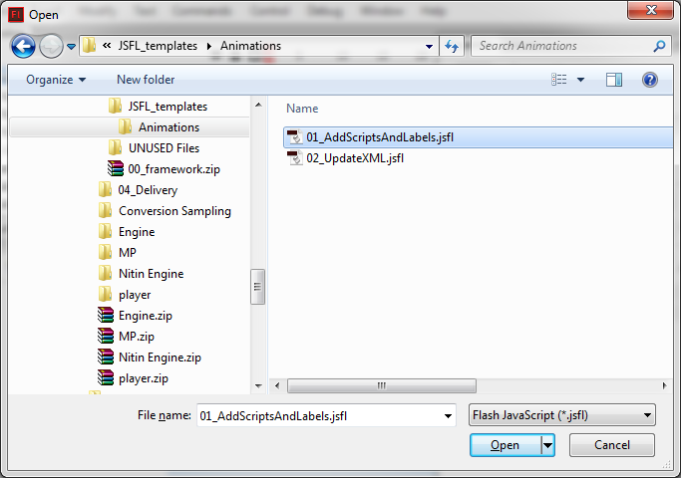

**Step 3:** Running this script will do the following:

* add the required "labels" and "script" to the flash timeline
* save a copy of the FLA source as **\*filename* + _swiffy.fla**.

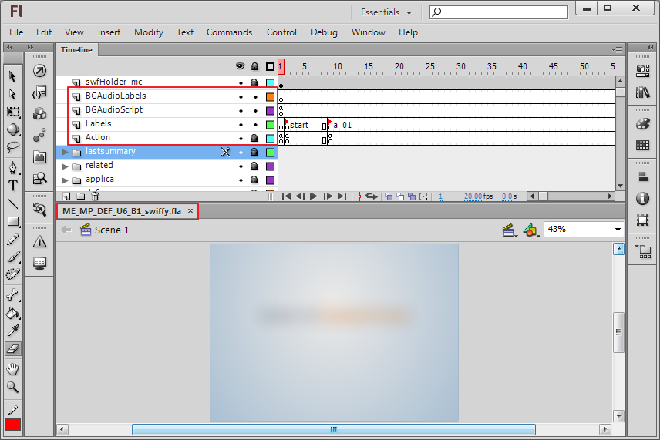

* generate a folder by the name of the FLA source file with the contents as shown below
* export the data required information in an XML named as **page.xml** as shown below
* export the audios used in the FLA's timeline to the **audio/en** folder as shown below
* It will also generate a file named **\*filename* + _swiffy.swf.html** (Do not delete this file before the entire process is finished). This file has the generated Swiffy SVG JSON object.

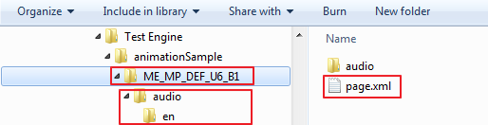

### Converting Audio Files from WAV to MP3

If the audios used in the FLA source are WAV files then this needs to be converted to MP3. Use audio converting software like audacity to convert the generated WAV files in the **audio/en** folder to MP3.

### Generating Swiffy HTML Output

**Step 1:** Go to **Commands > Export as HTML5 (Swiffy)**

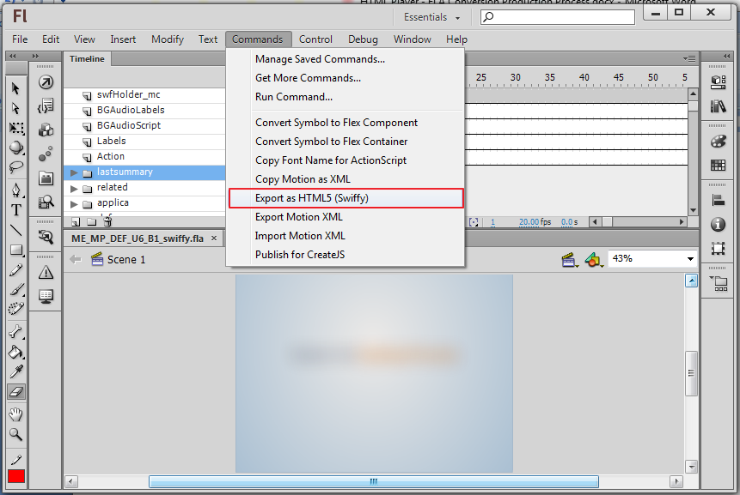

**Note:**

* Make sure that you are connected to the internet and have a decent (2MBPS or greater) connection speed.
* Also make sure if you get an error in the output window like "**The Swiffy webservice could not be reached. Please check your internet connection.**", then run Flash as Administrator.
* To run Flash as administrator click **Start menu > RIght click on Adobe Flash Professional > Run as administrator**

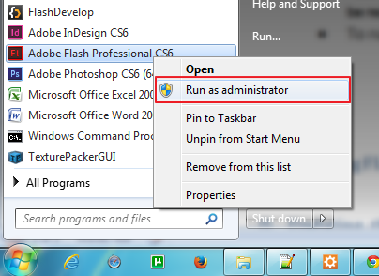

### Cleaning FLA files to generate clean Swiffy HTML output

After exporting you might see some Errors, Warnings and Info in the output panel as shown in the image below:

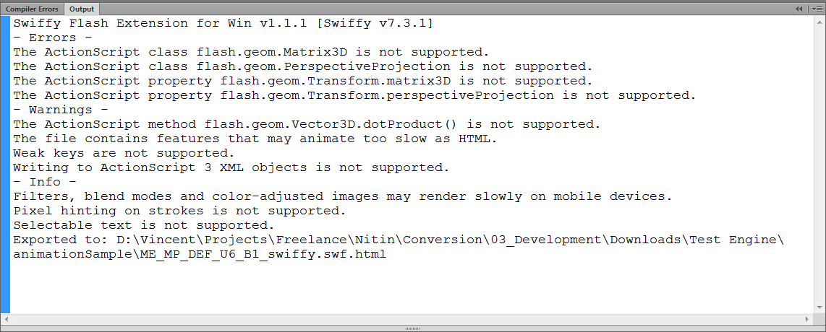

Some of the common things that are not supported while exporting are:

* Filters, blend modes and color-adjusted images may render slowly on mobile devices.
* Pixel hinting on strokes is not supported.
* Selectable text is not supported.
* All kinds of 3D transformations applied to objects (these transformations use some of the below mentioned class files:
  + flash.geom.Matrix3D
  + flash.geom.PerspectiveProjection
  + flash.geom.Transform.matrix3D
  + flash.geom.Transform.perspectiveProjection
  + flash.geom.Vector3D.dotProduct()
* SVG-based HTML5  output will **only run in the Webkit browsers** [Chrome and Safari effectively].Firefox may render these files but might crash the browser if the animations are too complex. Firefox renders the files, but would crash if heavy filters and blend modes have been used. The complex animation containing these, would need to be relooked into and an alternative needs to be decided.
* Some animations may animate too slow as HTML. **Complex animations may be slow** on mobile devices.
* Masked items may overlap and not be seen
* Swiffy conversion added 10-40% more to the original file size. For example, a converted file is 329KB versus the original Flash .swf files size of 241KB.
* Conversion of .swf files greater than 1MB will not be possible**.**
* Flash components do not get converted.
* Also please note that the Swiffy output will reduce the quality of the image files used in the SWF animations. This will be evident if there is an image present with text written over it (NOT FLASH TEXT).

**Note:** A process could be set where

* the Swiffy output is generated first, by deleting the audio layers and the "ui" class reference
* this would list the issues in the output panel
* evaluate how the generated output plays in each required browser.
* modify the animations to make them work in all browsers.
* put audio back in the FLA
* then run " 01_AddScriptsAndLabels.jsfl" and so on

### Updating the XML and generating the HTML page

Open the generated flash file named **\*filename* + _swiffy.fla** and do the following steps to generate the final output:

**Step 1:** Go to **Commands > Run Command**

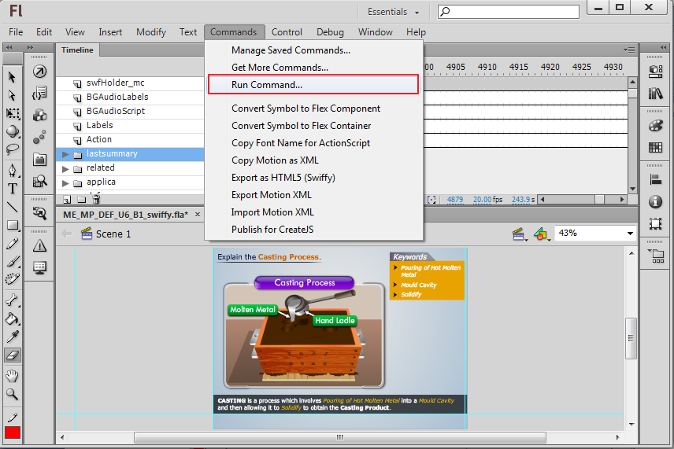

**Step 2:** Select the **02_UpdateXML.jsfl** file supplied in the **JSFL_templates/Animations** folder and **click Open**.

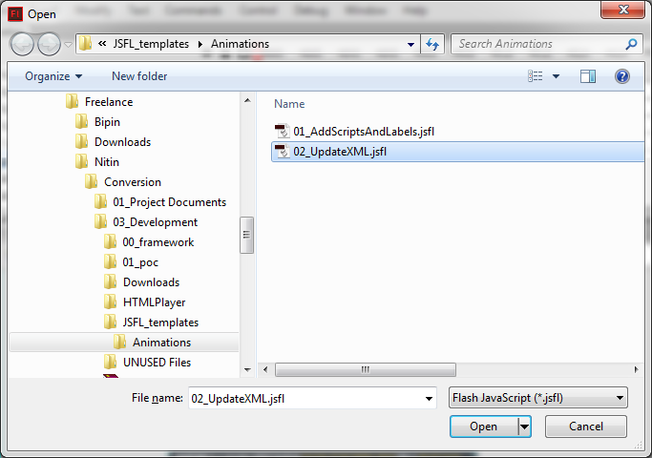

**Step 3:** Running this script will do the following:

* update the page.xml file with the required data from **\*filename* + _swiffy.swf.html** filegenerated in the earlier step
* generate a page.html markup required by the engine

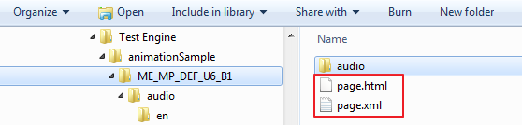

**Step 4:** Post Step 3 you can delete the **\*filename* + _swiffy.swf.html** file.

## Integrating Swiffy with the HTML player

**Step 1:** Folder structure of the player is as shown below:

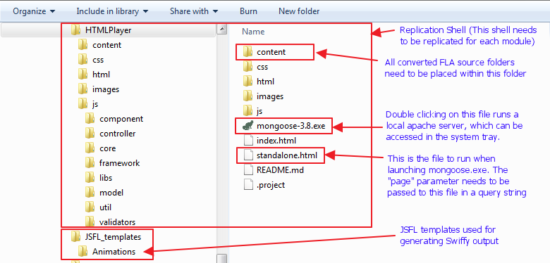

**Step 2:** Replicate the Shell folder and rename the HTMLPlayer folder to the name of the module / lesson required

**Step 3:** Place the page folder generated by following the steps in process 2 in the **content** folder shown above.

## Running the HTML Player for checking Swiffy HTML and MCQ HTML output

**Step 1:** Place all page folders generated by following the steps in process 2 in the **content** folder shown above.

**Step 2:** Double click on mongoose.exe to run it. It will appear in the system tray as shown in the image below:

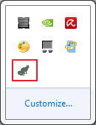

**Step 3:** **Left click** on the **mongoose icon** and select **Start browser** as shown below:

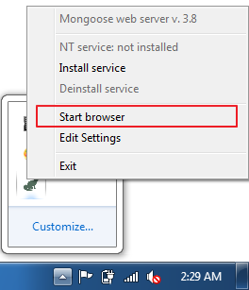

**Step 4:** This will launch the default browser and launch the index.html by default. Change the URL in the address bar to **http://localhost:8080/standalone.html**

**Step 5:** Add a query string parameter named "**page**" in the address bar as shown in below:

**http://localhost:8080/standalone.html?page=ME_MP_DEF_U6_B1**

where, "**ME_MP_DEF_U6_B1**" is the name of the **page folder placed within the content folder**

## Converting Quiz/MCQ flash files to generate HTML output

Below are the steps to convert Quiz activities to HTML.

**Note:** This process is not applicable to Tutorials or Numerals activities.

**Step 1:** Copy “quiz.jsfl” on to your desktop

**Step 2:** Open MCQ/quiz file (i.e. ME_AE_DIA_U6_B10_MCQ1.fla) in Flash CS5

**Step 3:** Select “Run Command” from **Commands** menu

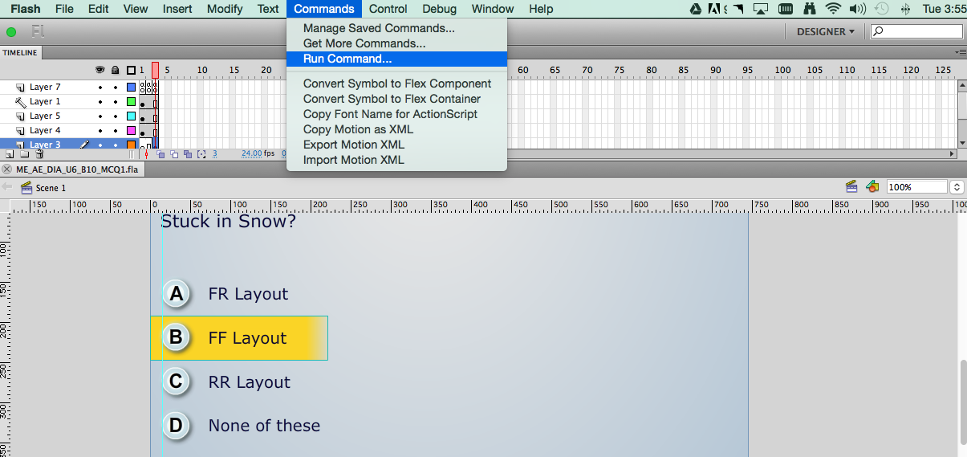

**Step 4:** Select “quiz.jsfl” from desktop

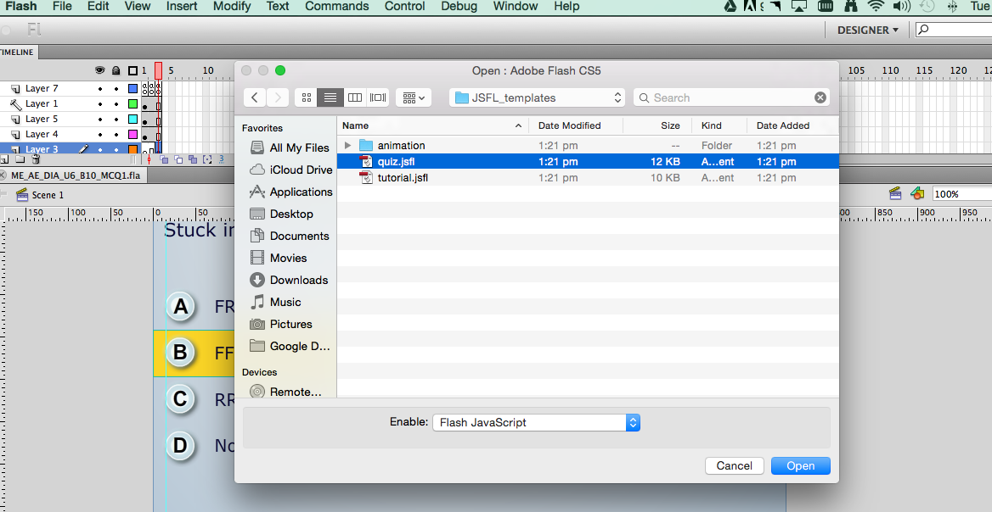

**Step 5:** This will initiate conversion process

**Step 6:** After successful conversion below alert message will be displayed to folder.

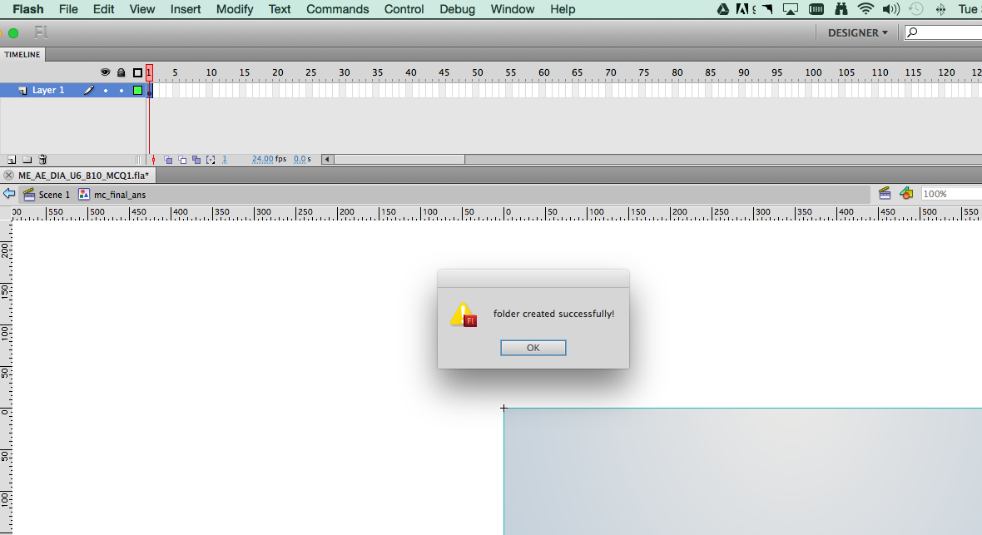

**Step 7:** A folder will be created with name of FLA file (i.e. ME_AE_DIA_U6_B10_MCQ1) on the same location where you have kept Quiz/MCQ file.

**Step 8:** This folder will contain below files

* 1. page.html
  2. page.xml
  3. bg.png

**Step 9:** Copy and paste entire folder in the "**content**” folder in the HTML Player folder

**Step 10:** Launch page using mongoose to preview the converted page. (Mongoose launch process is show above),